I | GENERAL
Client |  | /
Booking from |  | /
Supplier |  | /
Factory |  | /
Product Description |  | Scooter
PO No. |  | /
Item No. |  | /
Type of Inspection |  | Final random inspection
Order Qty: |  | 2500pcs
Shipment Qty: |  | 2500pcs
Production Status |  | 70% finished and 50% packed in carton
Inspection date |  | /
Inspection Location |  | / China
Inspector Name |  | Henry/Tom/Alice
Report approved by |  | William

OVERALL INSPECTION CONCLUSION
PASSED - Conform to Client’s Requirement  ON HOLD - Subject to Client’s Evaluation  FAILED - Not Conform to Client’s Requirement  ABORTED - The goods didn’t ready or others factory’s issue  ACTUAL FINDING - Recorded the actual inspection status for client ref | ON HOLD | Due to remarks

Sections | Result | Remark No.
A. Quantity Check
B. AQL Result (workmanship) | Actual finding | 8
C. Verification against sample  /documents | Actual finding | 2,7,
D. On-Site checking | To be confirmed by client | 3,4,5,6,
E. Marking and Packing | Actual finding | 1&9

Factory Informations
Factory cooperation | ☐ Good - Good cooperation and good manpower to assist.  ☑ Average - Just enough manpower to assist inspectors.  ☐ Poor - Manpower support, documents and equipment not sufficient.
Number of workers in factory claimed | ☐ Less than 50 people  ☐ 50-100 people  ☐ 100-500 people  ☑ 500-1000 people  ☐ More than 1000 people  ☐ Unknown
Production activity during inspection | ☐ Very busy  ☑ Normal activity  ☐ Low activity  ☐ N/A (Reasons: Inspector had no access to workshops. / Factory was unwilling to disclose information, etc)
Inspector’s personal judgment | ☐ Good - The factory was well organized and clean. Well maintenance and calibration of testing equipment.  ☑ Average - The factory was clean, and the testing equipment normally maintained.  ☐ Poor - The factory was not well organized, testing equipment not available / not workable.

II | REMARKS
- 70% finished and 50% is packed during inspection.
- No reference sample was provided for us to compare.
- No equipment was provided for us to do the motor power check. (Motor Rating Power: 350W required)
- No equipment was provided for us to do the charger Hi-pot test and battery.
- Factory refused to do carton drop test
- Factory didn’t agree to open the battery bag for inspection.
- 1pcs green label pasted on unit after checked by inspector
8. Battery power check, 7 bars for 2.4% (6pcs), 6 grids account for 72% (180pcs), 5 grids account for 22.8% (57pcs), and 4 grids account for 2.8% (7pcs).
9.The gift box was different from the artwork provided by client.

A | WORKMANSHIP
PO Number |  |  |  | Item Number | PO Quantity |  | Finished Products |  | Packed Quantity
Reference: ISO 2859, ANSI/ASQC Z1.4, BS 6001 |  |  |  |  |  | Defective Classification |  | Critical |  | Major | Minor
 |  |  |  |  |  | Inspection Plan |  | Fixed sample size
 |  |  |  |  |  | AQL |  | 0 |  | 1.0 | 2.5
 |  |  |  |  |  | Fixed sample Size |  | 250 |  | 250 | 250
Item No. |  | Qty Checked | Detail of Defectives |  |  |  |  | REJECTED QTY
/ |  | 250 | Poor installation of brake line |  |  |  |  | 0 |  | 0 | 1
 |  |  | Scratched mark |  |  |  |  | 0 |  | 9 | 0
 |  |  | Poor plastic spraying |  |  |  |  | 0 |  | 0 | 3
 |  |  | Headlamp bracket broken |  |  |  |  | 0 |  | 1 | 0
 |  |  | No nameplate attached |  |  |  |  | 0 |  | 0 | 1
 |  |  | Dirty stain |  |  |  |  | 0 |  | 0 | 5
 |  |  | Oil stain |  |  |  |  | 0 |  | 0 | 16
Total Found: |  |  |  |  |  |  |  | 0 |  | 10 | 26
Max. Allowed: |  |  |  |  |  |  |  | 0 |  | - | -
Result: |  |  |  |  |  |  |  | Actual finding

Selected product serial No.: total selected 250pcs
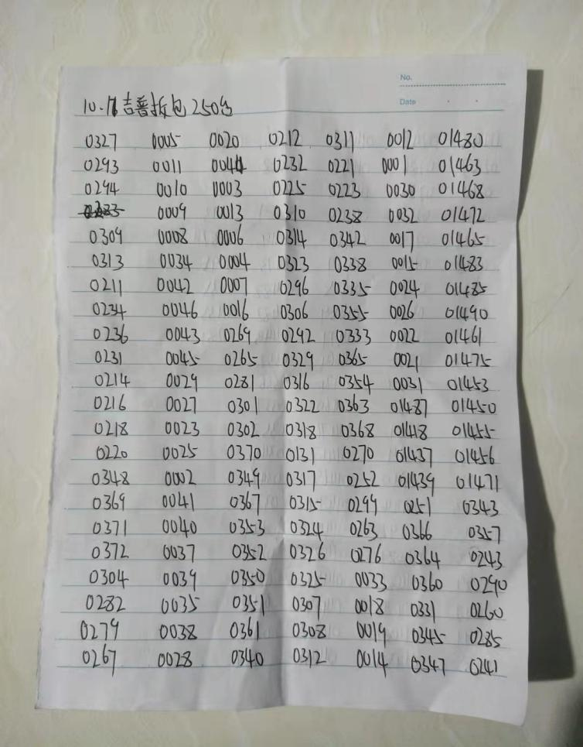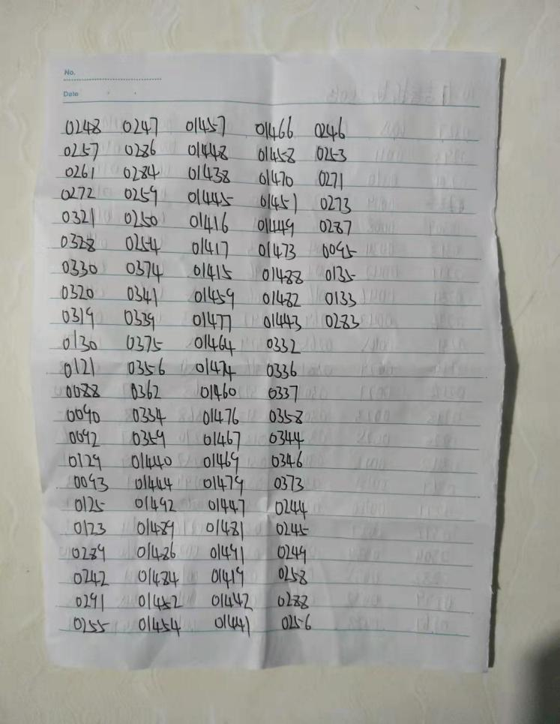

B | Verification against Sample/Documents

Client sample Supplier sample No sample
Supplementary information: Photo Purchase order Specification Others
 |  | Conform | Non conform | Comments
1. | Appearance |  |  | Actual finding
2. | Accessories |  |  | Actual finding
3. | Materials |  |  | Actual finding
4. | Packaging |  |  | Actual finding
5. | Labeling/Marking |  |  | Actual finding

C | On-Site checking

C1 |  | Safety & Reliability check
Test item |  |  | S/S | Criteria | Result | comments:
1 | Carton drop test |  | 1Carton | 45.7cm, 1corner, 3edges, 6sides | Passed Failed N/A | See remark 5
2 | 3M test |  | 3pcs | 3M tape for printing | Passed Failed N/A
3 | Rub test |  | 3pcs | rub 15s | Passed Failed N/A
4 | Barcode scanning check |  | 3pcs | By barcode scanner | Passed Failed N/A
5 | Battery Voltage after full charged |  | 3pcs | 36V | Passed Failed N/A | 41.8V
6 | Time of fully charged |  | 3pcs | 5hours | Passed Failed N/A | 7.49”
7 | Internal check |  | 3pcs | Refer to Spec. | Passed Failed N/A
8 | Battery capacity check |  | 1pc | 10.4Ah | Passed Failed N/A | 10.73Ah
9 | Burning test |  | 3pcs | No over heating | Passed Failed N/A
10 | Recharging check |  | 3pcs | No over heating | Passed Failed N/A
11 | Performance function check |  | 5pcs | Refer to Spec. | Passed Failed N/A
12 | Adaptor output voltage |  | 5pcs | 42V | Passed Failed N/A | 42V
13 | Power consumption |  | 1pc | - | Passed Failed N/A | See Remark 3
14 | Initial voltage of battery |  | 3pcs | - | Passed Failed N/A | 37.16-37.25V
15 | Hi-Pot |  | 0pcs | 3000V,5S,5mA | Passed Failed N/A | See Remark 4
16 | Waterproof check |  | 1pc | IPX4 | Passed Failed N/A
17 | Size check |  | 3pcs | - | Passed Failed N/A
18 | Weight check |  | 3pcs | - | Passed Failed N/A
19 | Loading test |  | 3pcs | 100kg | Passed Failed N/A
20 | Auto time power off |  | 3pcs | - | Passed Failed N/A | 3.13”
21 | Painting cross cut test |  | 3pcs | 3M tape | Passed Failed N/A

C2 | Measurement
Measurement point |  | Requirement | Ref. sample | Actual finding
 |  |  |  | Sample #1 | Sample #2 | Sample #3
Unit size(mm)- |  | 1195x1168 | -- | 1200x475x1175 | 1200x475x1175 | 1200x475x1175
Unit folding size (mm)- |  | 1195x515 | -- | 1195x475x515 | 1195x475x515 | 1195x475x515
Unit Net weight (kg) |  | 19 | -- | 18.755 | 18.755 | 18.755
Unit GROSS weight (kg) |  | 22.8 | -- | 22.31 | 18.96 | 19.12
Outer diameter of wheel (inch) |  | 10” | 10” | 10” | 10” | 22.36
Poly bag label size (cm) |  | -- | - | -- | 22.36 | 22.36
Power cord to plug (cm) |  | - | - | - | -- | --
Total length of power cord |  | - | - | 274.5cm | - | -
Power cord to adaptor(cm) |  | - | - | - | 274.5cm | 274.5cm
Climbing Degree |  | 15° | - | 15° | - | -
MAX loading |  | 100kg | - | 100kg | 15° | 15°
CE logo height (mm) |  | - |  | 4 | 100kg | 100kg
WEEE logo height (mm) |  | - |  | 4 | 4 | 4

D1 | Marking and Packing

Outer Pack | Corrugated Paper Plies: | Single Wall Double Wall Triple Wall
 | Fastening: | Metal Staples Glue
 | Sealed by: | Kraft Tape Opaque Gummed Tape  Transparent Gummed Tape with Two dots logo
 | Strapping: | Nylon Band pcs No
Unit pack | Each adaptor/screw packed in small polybag; each set packed in color box.

 | D2 | Packing % shipping informations
Item No. |  |  | Shipment quantity |  | Weight/ctn (kg) | Carton size  (cm) | Unit packing | pcs/inner packing | Pcs/ctn
 |  |  | Pieces | Cartons
/ |  |  | 2500 | 2500 | 22.31 | 122.8*20.5*53.8 | Gift box | - | 1

E | Photos
warehouse | warehouse
Inspected sample | Pass label
color box view | color box view
color box view | color box view
color box view | color box view
color box view | Sticker view
color box view | color box view
color box view | Barcode view
Barcode scan view | color box view
color box view | color box view
color box view | Sticker view
color box view | color box view
color box view | color box view
color box view | color box view
color box view | color box view
color box view | color box view
color box view | color box view
Open color box view | Product view
Product view | Product view
Product view | Product view
Product view | Product view
Product view | Product view
Product view | Product view
Product view | Product view
Product view | Product view
Product view | Product view
Product view | Product view
Product vie w | Product view
Product view | Product view
Product view | Product view
Product view | Product view
Product view | Product view
Product view | Product view
Product view | Product view
Product view | Product view
Product view | Product view
Product view | Product view
Product view | Product view
Product view | Product view
Product view | Product view
Product view | Accessories
Accessories | Accessories
Accessories | Accessories
Accessories | Accessories
Accessories | Accessories
Accessories | Accessories
Accessories | Accessories
Accessories | Accessories
Accessories | Accessories
Accessories | Accessories
Accessories | Accessories
Accessories | Accessories
Carton weight check | Carton weight check
Product weight inspection | Product weight inspection
Carton size inspection | Carton size inspection
Carton size inspection | Carton size inspection
Carton size inspection | Carton size inspection
Product dimension inspection | Product dimension inspection
Product dimension inspection | Product dimension inspection
Product dimension inspection | Product dimension inspection
Product folding dimension inspection | Product folding dimension inspection
Total length inspection of power cord | Total length inspection of power cord
Wheel dimension check | Wheel dimension check
Wheel dimension check | Wheel dimension check
Instrument dimension inspection | Instrument dimension inspection
Instrument dimension inspection | Instrument dimension inspection
Tag size check | Tag size check
Tag size check | Tag size check
Tag size check | Tag size check
Manual size checking | Manual size checking
Manual size checking | Manual size checking
Manual size checking | Manual size checking
on site test:
Logo tape test | Logo tape test
Initial battery voltage check | Initial battery voltage check
Battery full voltage check | Load test
Light check | Light check
Instrument function inspection | Instrument function inspection
Instrument function inspection | Instrument function inspection
Constant speed cruise function check | Constant speed cruise function check
Constant speed cruise function check | Constant speed cruise function check
Automatic instrument shutdown time check | Automatic instrument shutdown time check
Bluetooth connection function check | Bluetooth connection function check
Bluetooth connection function check | Bluetooth connection function check
Bluetooth connection function check | Bluetooth connection function check
Waterproof test | Waterproof test
Waterproof test | Waterproof test
Wheel internal inspection | Controller internal inspection
Controller internal inspection | Instrument internal inspection
Instrument internal inspection | Charging time check
 | 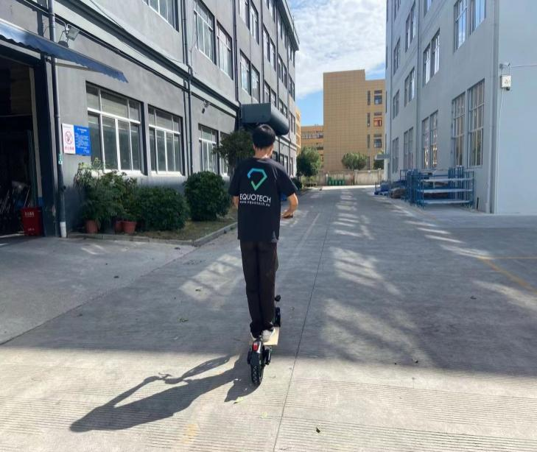
Charging time check | Ride function check
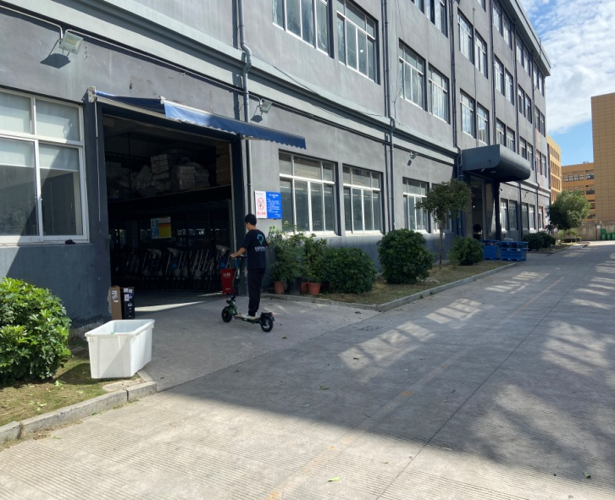
Ride function check | Cross cut test
Rubbing test | Rubbing test
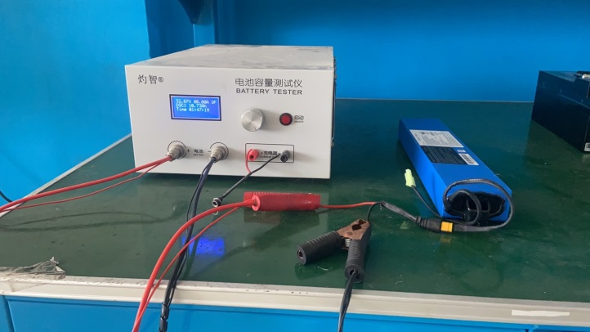 | 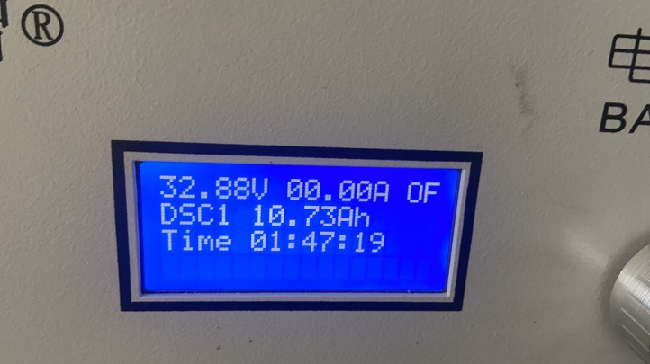
Capacity check | Capacity check
Minor defect: Poor installation of brake line | Major defect: Scratched mark
Major defect: Scratched mark | Major defect: Scratched mark

End of the Photographic Report

If you have any question, please contact us:

Account Manager - Customer service  E: witty@equotech.cn | General Manager  E: william@equotech.cn

***************************************************************************************************************************
The above reflects our findings at time and place of inspection. This report does not relieve sellers/ suppliers from their contractual obligations with regard to quantity and/or quality of this delivery. This report is issued without prejudice to liability and the information contained herein is to the best of our knowledge and belief, true and correct. This document shall not be reproduced either in full or in part except with written approved by the Authorized Representative of Equotech.
Note:
1. This report reflects our findings at the time and the place of inspection based on random samples selected.
2. This inspection was carried out to the best of our knowledge and abilities, and our responsibility is limited to the exercise of reasonable one.
3. This report does not relieve the sellers from their contractual obligations nor does it prejudice buyer’s right for compensation for any apparent and/or hidden defects not detected during our inspection or occurring thereafter.
4. This report does not evidence shipment.
5. This report's inspection results only relate to the samples as (randomly picked) by our inspector.

LIABILITY AND INDEMNIFICATION
(a) Limitation of Liability:
(1) Equotech is neither an insurer nor a guarantor and disclaims all liability in such capacity. Clients
seeking a guarantee against loss or damage should obtain appropriate insurance.
(2) Reports of Findings are issued on the basis of information, documents and/or samples provided by, or on behalf of, Client and solely for the benefit of Client who is responsible for acting as it sees fit on the basis of such Reports of Findings. Neither Equotech nor any of its officers, employees, agents or subcontractors shall be liable to Client nor any third party for any actions taken or not taken on the basis of such Reports of Findings nor for any incorrect results arising from unclear, erroneous, incomplete, misleading or false information provided to the Equotech.
(3) Equotech shall not be liable for any delayed, partial or total non-performance of the services arising directly or indirectly from any event outside Equotech’s control including failure by Client to comply with any of its obligations hereunder.
(4) Equotech shall have no liability for any indirect or consequential loss including without limitation loss of profits, loss of business, loss of opportunity, loss of goodwill and cost of product recall. It shall further have no liability for any loss, damage or expenses arising from the claims of any third party (including, without limitation, product liability claims) that may be incurred by the Client.
(b)Indemnification: Client shall guarantee, hold harmless and indemnify Equotech and its officers, employees, agents or subcontractors against all claims (actual or threatened) by any third party for loss, damage or expense of whatsoever nature including all legal expenses and related costs and howsoever arising relating to the performance, purported performance or non-performance, of any services.

**************************************************************End***********************************************************

